- Enable linux beta and follow setup steps; link here
https://chromeunboxed.com/the-command-line-getting-started-with-linux-apps-on-your-chromebook/

- enable file sharing
- Download Linux Dynalist package from here
https://dynalist.io/download
- The package will probably default to the Downloads folder on chromebook; it is called this
dynalist.tar.gz
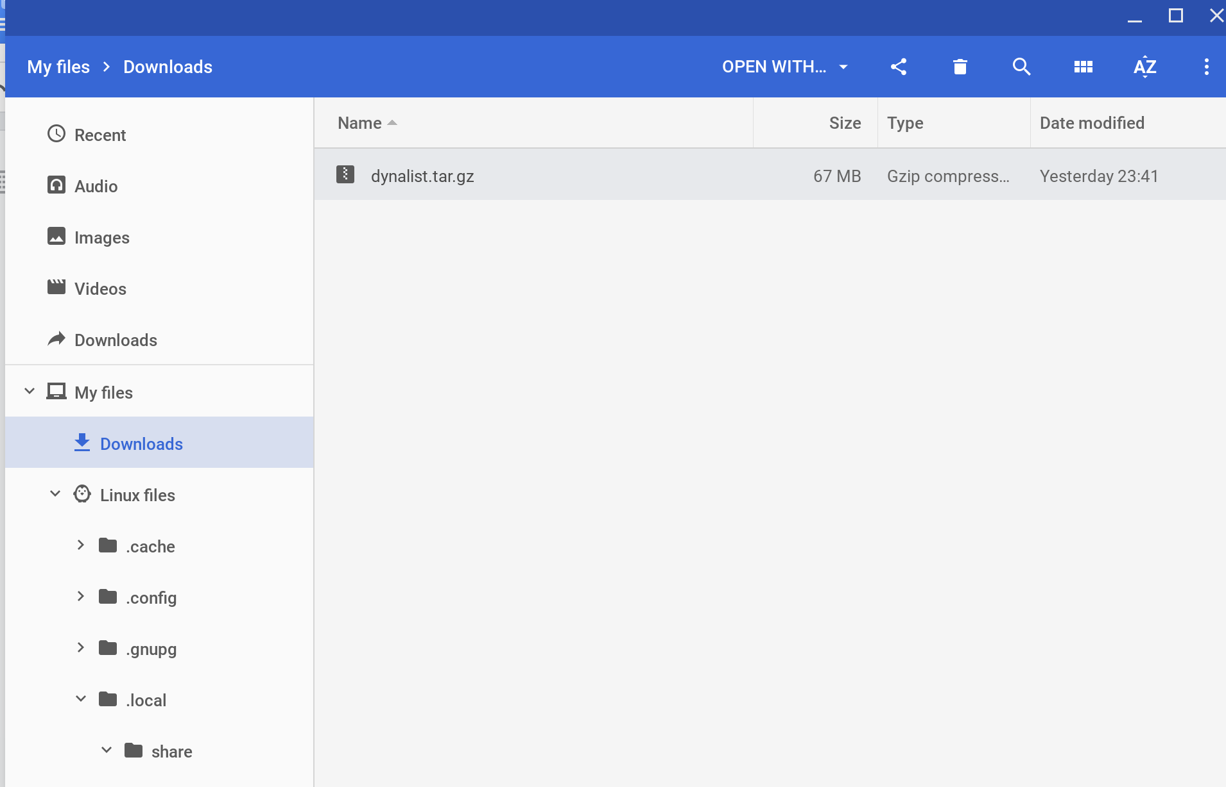

- Go to Linux files in the Chrome Files App; enable Show hidden files from the 3 dot menu

- Navigate to .local/share
- Create a folder called applications if doesn't already exist
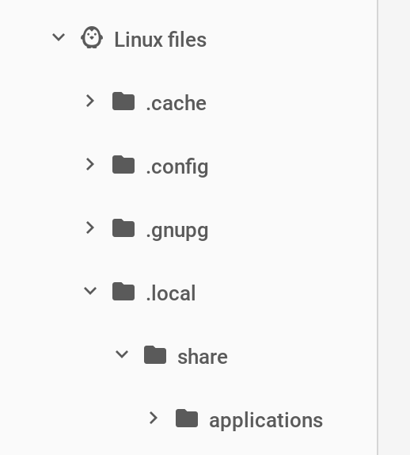
- Copy dynalist.tar.gz from Downloads to .local/share/applications using the Chrome Files App
- Launch linux Terminal;
- run
$ sudo apt install libnss3-dev
This helps with some compatibility problems
- change directory to point to .local/share/applications
$ cd ./local/share/applications
- Then unpack the tar.gz file using this command
$ tar -zxvf dynalist.tar.gz
- This will create a folder called .local/share/applications/dynalist-1.0.5 (note this is the version of dynalist I downloaded, the version numbers will change. All the dynalist application files are within this folder.
- Create a desktop entry (link on how to do this is here) using Text Chrome App
https://support.google.com/pixelbook/thread/708306?hl=en
I created the following script
[Desktop Entry]
Name=Dynalist
Comment=Dynalist
GenericName=Dynalist
X-GNOME-FullName=Dynalist
Exec=/.local/share/applications/dynalist-1.0.5/dynalist
Terminal=false
Type=Application
Icon=dynalist-esr
Categories=Network;Dynalist

and saved it as dynalist.desktop like this
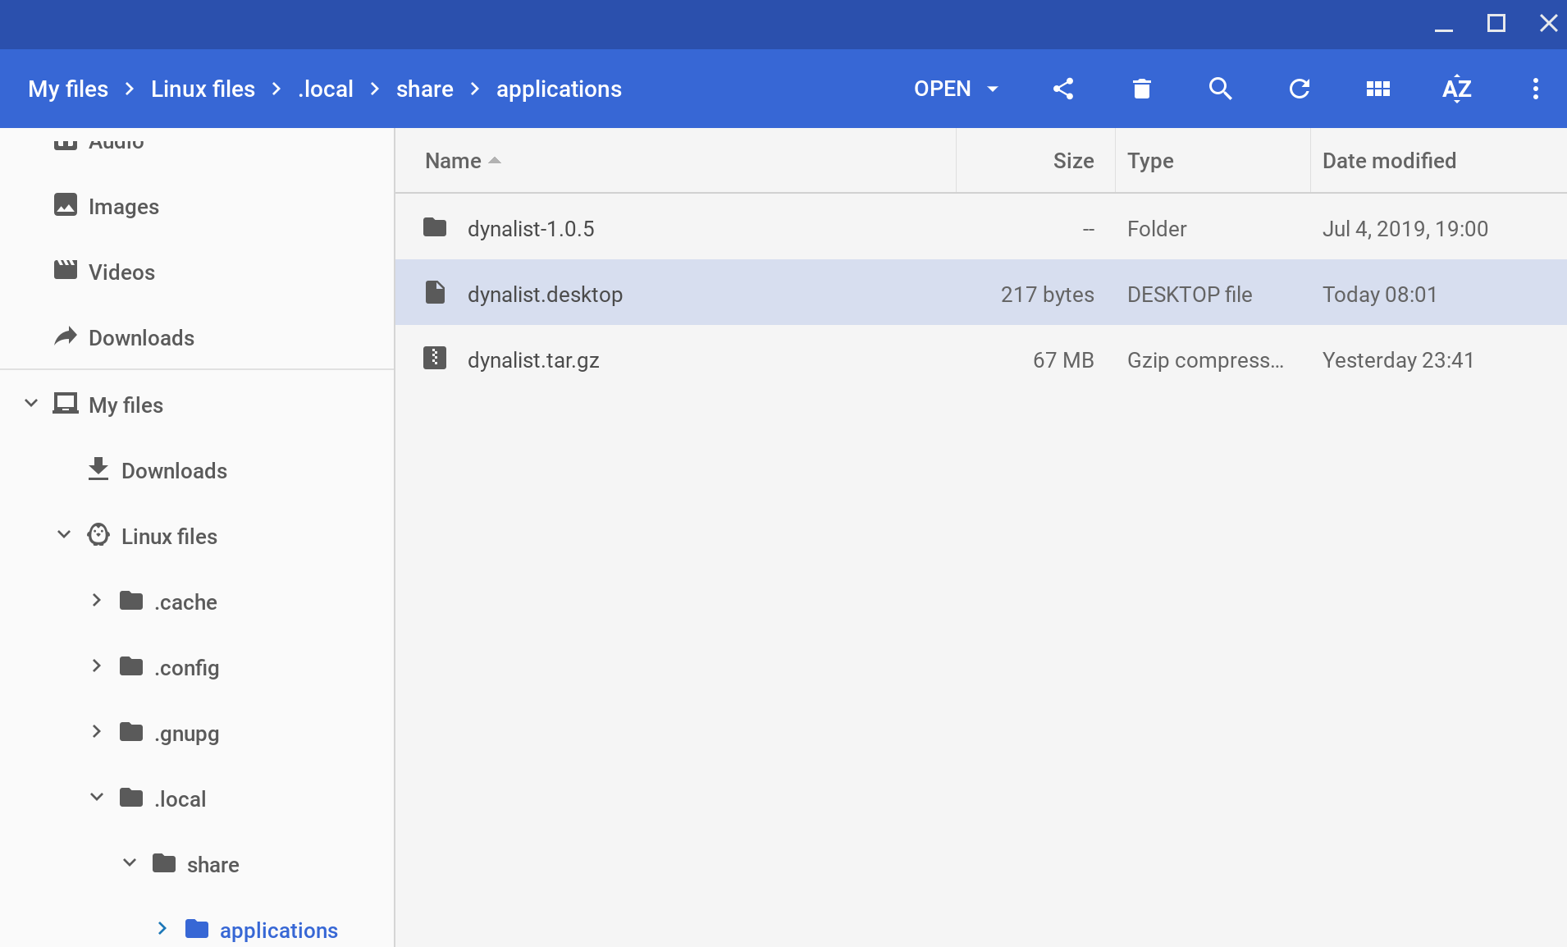
- Change directory again to
$ cd ./local/share/applications/dynalist-1.0.5
- Then launch Dynalist as follows
./dynalist
i.e.
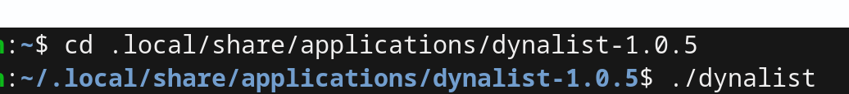

- Dynalist will launch!
It may first show up as a penguin icon
But it you reboot and search for Dynalist you should see the real icon; which you can pin to the launcher bar
